

Week Report – Week 4

Student: Fatima Hajji
Email:
- fatima.hajji@student.vives.be
- Fatima.HAJJI-EXT@um6p.ma
Phone: +212709173444

Host Institution: International Water Research Institute (IWRI),
Mohammed VI Polytechnic University (UM6P)
Address: Benguerir, Morocco

Local Supervisors:
Prof. Dr. Yassin Ait Brahim
Prof. Dr. Ismail Karaoui
Dr. Athmane Khettouch

Academic Supervisor (VIVES):
Dr. Andy Louwyck

Date: 27/02/2026

This week focused on exploratory analysis of NDVI and ERA5 data and on implementing methodological improvements following supervisor feedback.

- Exploratory Data Analysis
At the beginning of this phase, I developed an Exploratory Data Analysis (EDA) notebook to understand the relationship between vegetation dynamics (NDVI) and hydroclimatic variables (ERA5).
The EDA notebook is available in the project repository: https://github.com/FatimaVives/hydro-dynamics-oasis/tree/main/notebooks

Data Preparation
The following preprocessing steps were completed:
- Cleaned NDVI and ERA5 CSV files
- Standardized date formats
- Converted temperature from Kelvin to °C
- Converted precipitation and evapotranspiration from meters to mm
- Ensured evapotranspiration values were positive
- Merged datasets
- Checked missing values (none detected)
- Checked statistical distributions and potential outliers
- Performed correlation analysis

- Main Findings from EDA (2018–2023)
Descriptive Statistics (Monthly Aggregates, 2018–2023)
- Mean monthly NDVI ≈ 0.19
- Mean monthly precipitation ≈ 160 mm
- Mean monthly evapotranspiration ≈ 163 mm
- Mean monthly temperature ≈ 16.5 °C
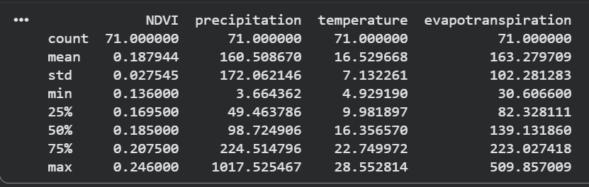
Hydroclimatic variability was significantly higher than NDVI variability. In arid oasis systems, vegetation dynamics are not directly controlled by surface rainfall alone. Surface water is often limited and vegetation largely depends on groundwater availability. Therefore, NDVI variation reflects overall water availability rather than immediate precipitation inputs.

Same-Month Correlation Analysis
Correlation with NDVI:
- Precipitation → 0.06 (almost no direct relationship)
- Temperature → −0.47 (moderate negative correlation)
- Evapotranspiration → 0.37 (moderate positive correlation)
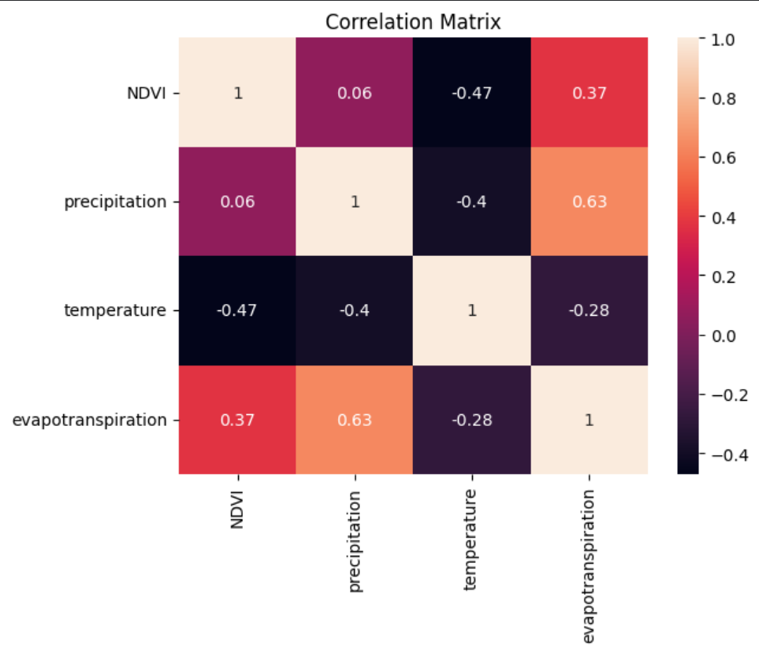
Interpretation:
- Vegetation does not respond directly or immediately to rainfall events, likely because plant activity is strongly influenced by groundwater availability and stored soil moisture rather than short-term surface precipitation.
- Higher temperature is associated with lower NDVI (heat stress effect).
- ET partly reflects vegetation transpiration activity.

Lag Effect (1 Month)
Since vegetation often reacts with delay, lagged variables were tested.
Results:
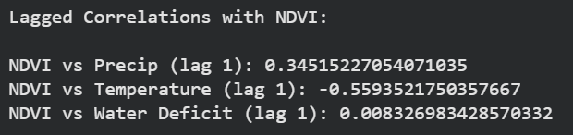
Key insight:
Vegetation response improves when considering previous month climate conditions, especially temperature. This confirms the presence of temporal memory in the system.
In arid environments, vegetation response is often linked to cumulative water availability, including groundwater recharge, which explains delayed and buffered NDVI dynamics.

- Meeting with Supervisors
After presenting the EDA results, we had a meeting to discuss methodology and improve the scientific robustness of the project.
The main feedback and tips were:
- Convert shapefile projection to WGS84 using .to_crs() in GeoPandas
- Work spatially, not only temporally
- Use ERA5 monthly aggregates instead of hourly data
- Use mean() instead of sum() for hydro variables
- Define water balance as P − ET
- Extend analysis to 2015–2025
- Extract a small zone for spatial focus
- Explore degradation indicators such as UVCI, VHI and TCI

- Adjustments Implemented After the Meeting
Projection Correction: The shapefile was originally in Merchich / Nord Maroc projection. Using GeoPandas, it was converted to WGS84 (EPSG:4326) to ensure compatibility with Google Earth Engine.
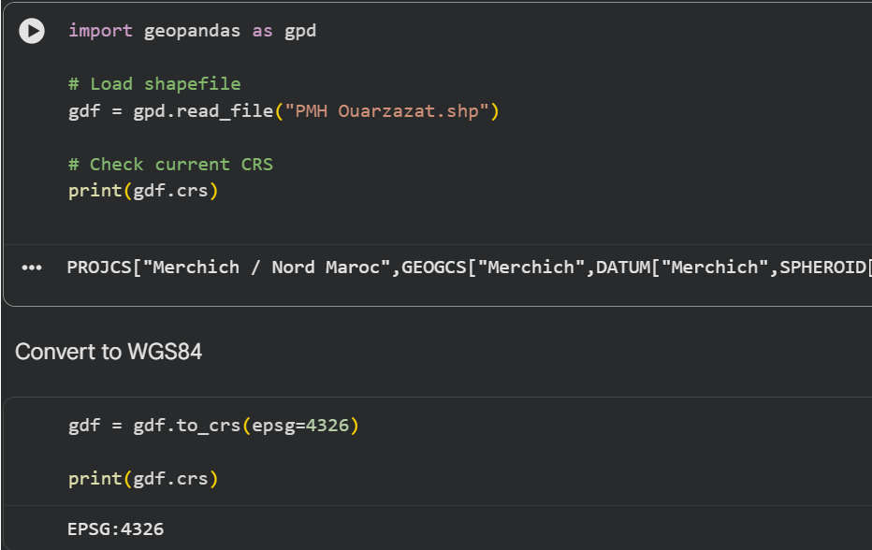

Extraction of a Sub-Zone (Skoura): Instead of analysing the entire shapefile, a smaller sub-zone (Skoura) was extracted
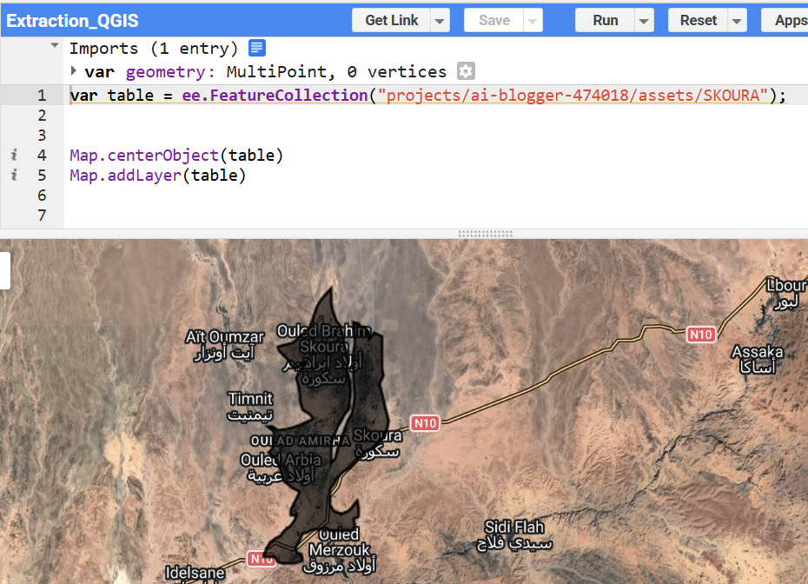
This allows more controlled spatial analysis and clearer interpretation.
Extension of Analysis Period: The study period was extended to 2015–2025 using Sentinel-2 (from mid-2015 onward).

- Work Still Ongoing
The next steps include:
- Transition from temporal averages to spatial NDVI analysis
- Correcting the water balance formulation to P − ET and re-evaluating correlations.
- Exploring degradation indices (UVCI, TCI, VHI).
- Computing spatial water balance maps.
- Comparing NDVI trends with hydroclimatic spatial variability.
These steps will further align the project with the objectives defined in the Plan and prepare the dataset for the modelling phase.

